**Lab**

**Name -Piyush dubey**

**Reg no -17bce1285**

**Code 1**

<!DOCTYPE html>

<html lang="en" xmlns="http://www.w3.org/1999/xhtml">

<head>

<meta charset="utf-8" />

<title></title>

<style>

body{

background-color:grey;

font-size:20px;

}

.button1

{

height:30px;

width:80px;

border-radius:5px;

margin-top:50px;

text-transform:uppercase;

}

</style>

</head>

<script>

function abc() {

var date = document.getElementById("d").value;

document.getElementsByTagName("h1")[0].innerHTML = "WOMEN EMPOWERMENT";

document.getElementById("date").innerHTML = date;

document.getElementById("con").innerHTML = "Women's empowerment is the process in which women elaborate and recreate what it is that they can be, do, and accomplish in a circumstance that they previously were denied. Empowerment can be defined in many ways, however, when talking about women’s empowerment, empowerment means accepting and allowing people (women) who are on the outside of the decision-making process into it. “This puts a strong emphasis on participation in political structures and formal decision-making and, in the economic sphere, on the ability to obtain an income that enables participation in economic decision-making.” Empowerment is the process that creates power in individuals over their own lives, society, and in their communities. People are empowered when they are able to access the opportunities available to them without limitations and restrictions. Feeling entitled to make your own decisions creates a sense of empowerment. Empowerment includes the action of raising the status of women through education, raising awareness, literacy, and training. Women's empowerment is all about equipping and allowing women to make life-determining decisions through the different problems in society.";

}

</script>

<body>

<h1 align="center">HUMAN TRAFFICING</h1>

<h2 align="right" style="margin-right:130px;">~Christop</h2>

<h2 align="right" id="date" style="margin-right:130px;">12.02.2018</h2>

<p id="con" style="margin-left:30px;margin-right:30px;">Human trafficking is the trade of humans for the purpose of forced labour, sexual slavery, or commercial sexual exploitation for the trafficker or others. This may encompass providing a spouse in the context of forced marriage, or the extraction of organs or tissues, including for surrogacy and ova removal. Human trafficking can occur within a country or trans-nationally. Human trafficking is a crime against the person because of the violation of the victim's rights of movement through coercion and because of their commercial exploitation. Human trafficking is the trade in people, especially women and children, and does not necessarily involve the movement of the person from one place to another.</p>

<br /><br /><br /><br />

<p style="margin-left:30px;">Change the article according to date:

<input type="date" id="d" name="d1" /><br />

<input type="button" id="button1" value="submit" name="b1" onclick="abc()" class="button1"/>

<!--<input type="button" id="button2" value="submit" name="b1" onclick="abc()"/>-->

</p>

</body>

</html>

Output

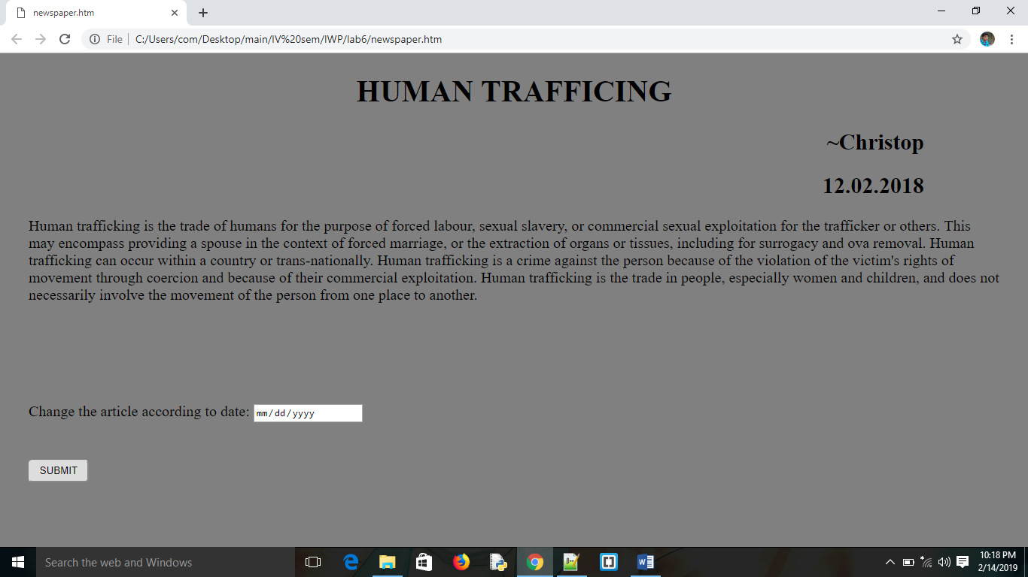

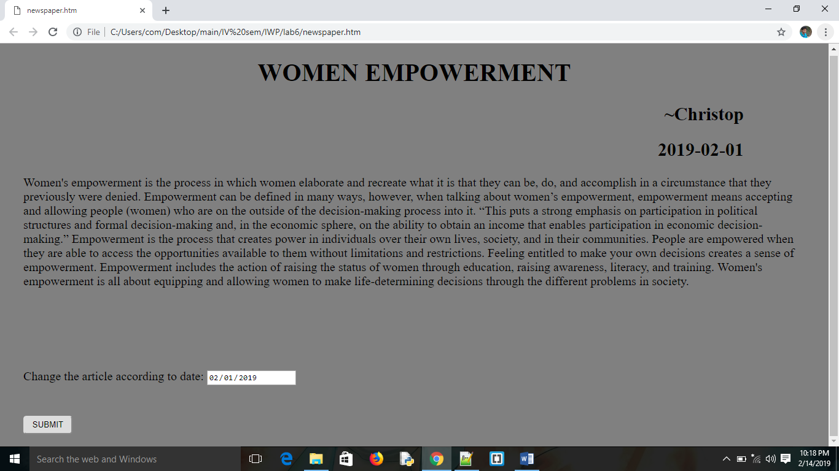

Code2

<!DOCTYPE html>

<html lang="en" xmlns="http://www.w3.org/1999/xhtml">

<head>

<meta charset="utf-8" />

<title></title>

<style>

* {

box-sizing: border-box;

}

.column {

float: left;

width: 50%;

padding: 10px;

height: 300px; /* Should be removed. Only for demonstration */

}

.row:after {

content: "";

display: table;

clear: both;

}

body{

background-color:grey;

color:white;

}

</style>

</head>

<script>

function abc() {

var x = document.createElement("IMG");

x.setAttribute("src", "creative.jpg");

x.setAttribute("width", "304");

x.setAttribute("height", "228");

x.setAttribute("alt", "The Pulpit Rock");

document.body.appendChild(x);

}

function xyz() {

var x = document.createElement("IMG");

x.setAttribute("src", "creative.jpg");

x.setAttribute("width", "304");

x.setAttribute("height", "228");

x.setAttribute("alt", "The Pulpit Rock");

document.body.appendChild(x);

}

</script>

<body>

<div class="row">

<div class="column">

<h1 align="center"> Use the color of the sky</h1>

<p id="con" style="margin-left:30px;margin-right:30px;">

A creative way to promote your product is to use the billboard in order to showcase some of the advantages of your product. You can use the color of the sky, the birds or just the billboard itself as a part of your commercial.

</p>

<br />

<p style="margin-left:30px;">

<input type="button" id="button1" value="Display AD" name="b1" onclick="abc()" />

<!--<input type="button" id="button2" value="submit" name="b1" onclick="abc()"/>-->

</p>

</div>

<div class="column">

<h1 align="center"> Use the color of the sky</h1>

<p id="con" style="margin-left:30px;margin-right:30px;">

A creative way to promote your product is to use the billboard in order to showcase some of the advantages of your product. You can use the color of the sky, the birds or just the billboard itself as a part of your commercial.

</p>

<br />

<p style="margin-left:30px;">

<input type="button" id="button1" value="Display AD" name="b1" onclick="xyz()" />

</p>

</div>

</div>

</body>

</html>

Output

